

**Adama Science and Technology University**

**School of Electrical Engineering and Computing**

**Course Title:**Electronic Circuit I

**Course Number:**ECE2101

Assignment

**Prepared by:**

**Name:**

**ID:**

**Section:**

**Submitted to: Sir Gebretsadquan**

Submission date: Nov 28, 2018

**Acknowledgement**

We would like to acknowledge our lab assistantfor his support and explanation in the laboratory. Through the group work and experiment we were able to comprehend the topics that were raised and able to communicate with each other well.

**Theoretical Background**

Rectification is a process whereby an applied waveform of **zero average value** is changed to one that **has a dc level**. For applied signals of more than a few volts, the ideal diode approximations can normally be applied.

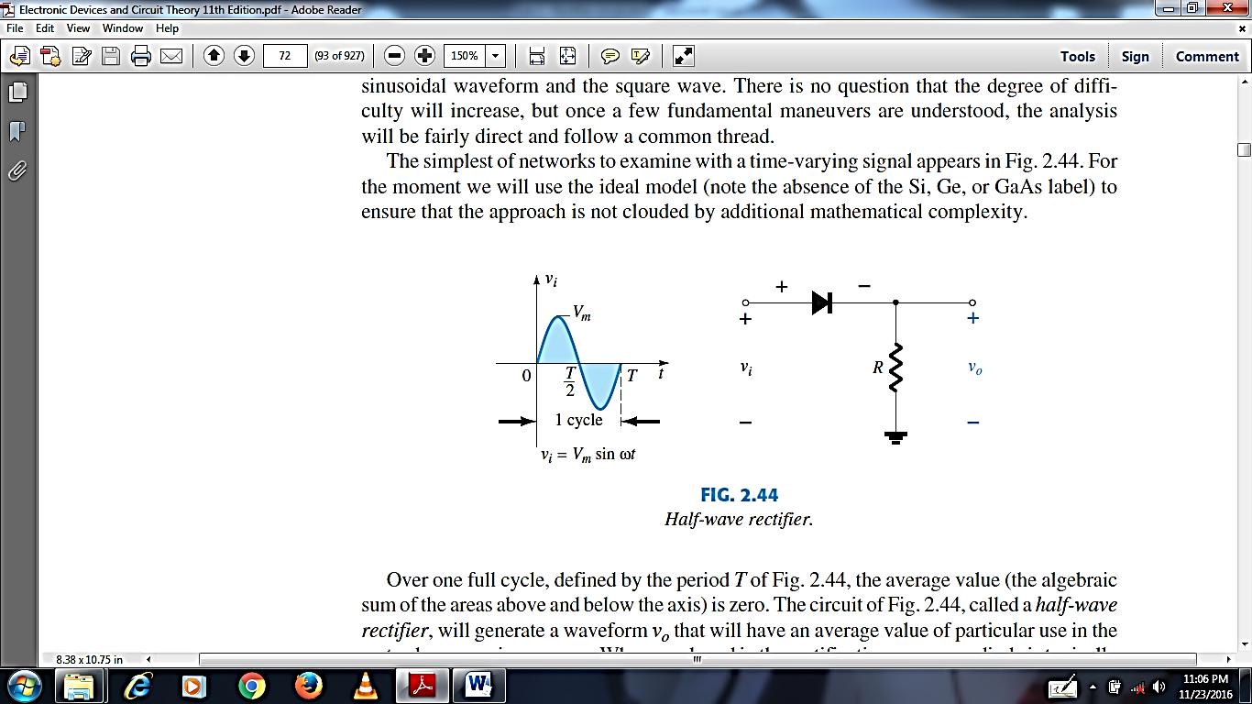

Figure 1: Half-wave rectifier

Over one full cycle, defined by the period *T* of Figure 1, the average value (the algebraic sum of the areas above and below the axis) is zero. The circuit of Figure 1, called a *half-wave rectifier,* will generate a waveform *vo*that will have an average value of particular use in theac-to-dc conversion process. When employed in the rectification process, a diode is typicallyreferred to as a *rectifier.* Its power and current ratings are typically much higher than thoseof diodes employed in other applications, such as computers and communication systems.

During the interval *t* = 0 to t = *T*/2 in Figure 1, the polarity of the applied voltage *vi*is suchas to establish “pressure” in the direction indicated and turn on the diode with the polarityappearing above the diode. Substituting the short-circuit equivalence for the ideal diode willresult in the equivalent circuit of Figure 2, where it is fairly obvious that the output signalis an exact copy of the applied signal. The two terminals defining the output voltage areconnected directly to the applied signal via the short-circuit equivalence of the diode.

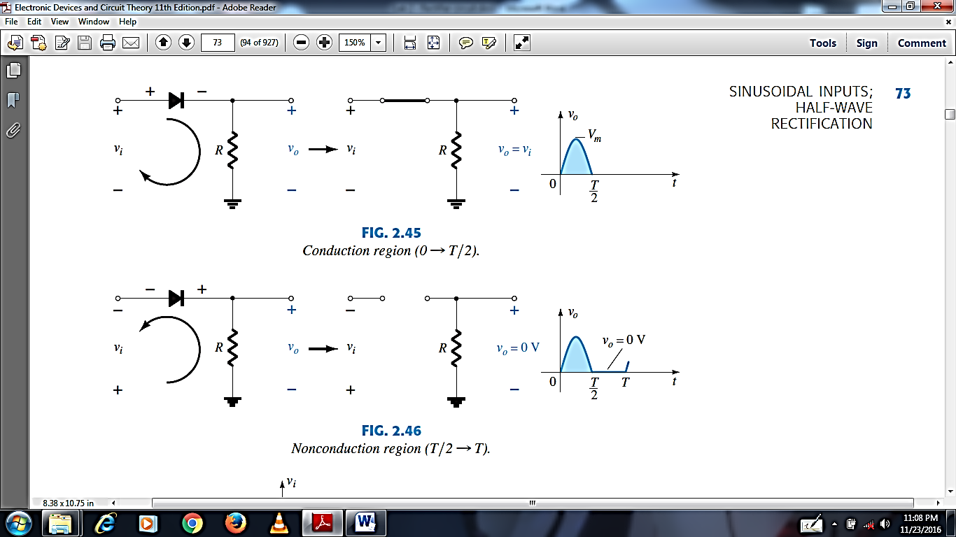

Figure 2: Conduction (0 to T/2)*.*



Figure 3: Non conduction (T/2 to T)

For the period *T*/2 to *T*, the polarity of the input *vi*is as shown in Figure 3, and the resulting polarity across the ideal diode produces an “off” state with an open-circuit equivalent. The result is the absence of a path for charge to flow, and ***vo*= *iR*= (0)*R*= 0 V** for the period *T/2 to T*. The input *vi*and the output *vo* are sketched together in Figure 4 for comparison purposes. The output signal *vo*now has a net positive area above the axis overa full period and an average value determined by:

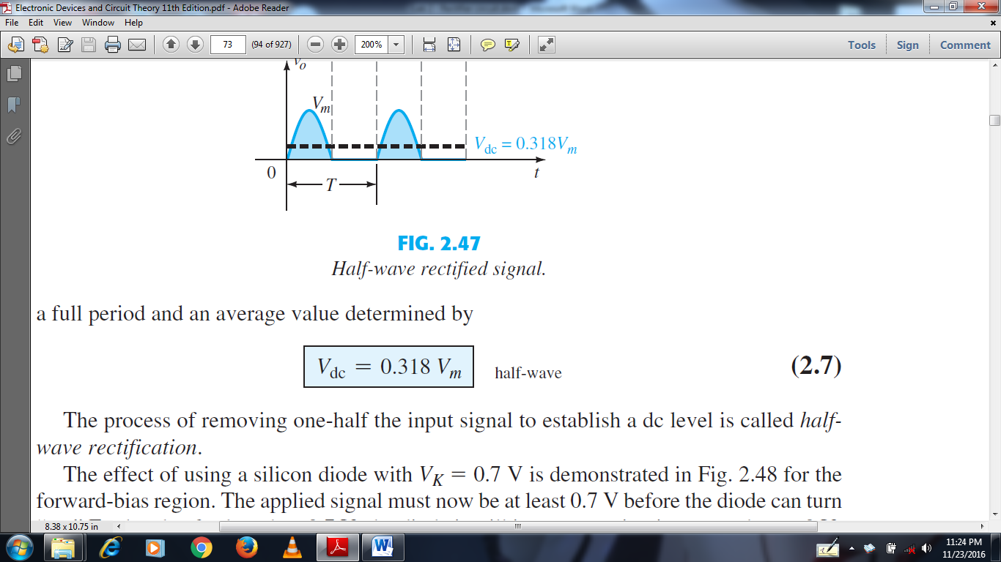

The process of removing one-half the input signal to establish a dc level is called *half wave rectification.*

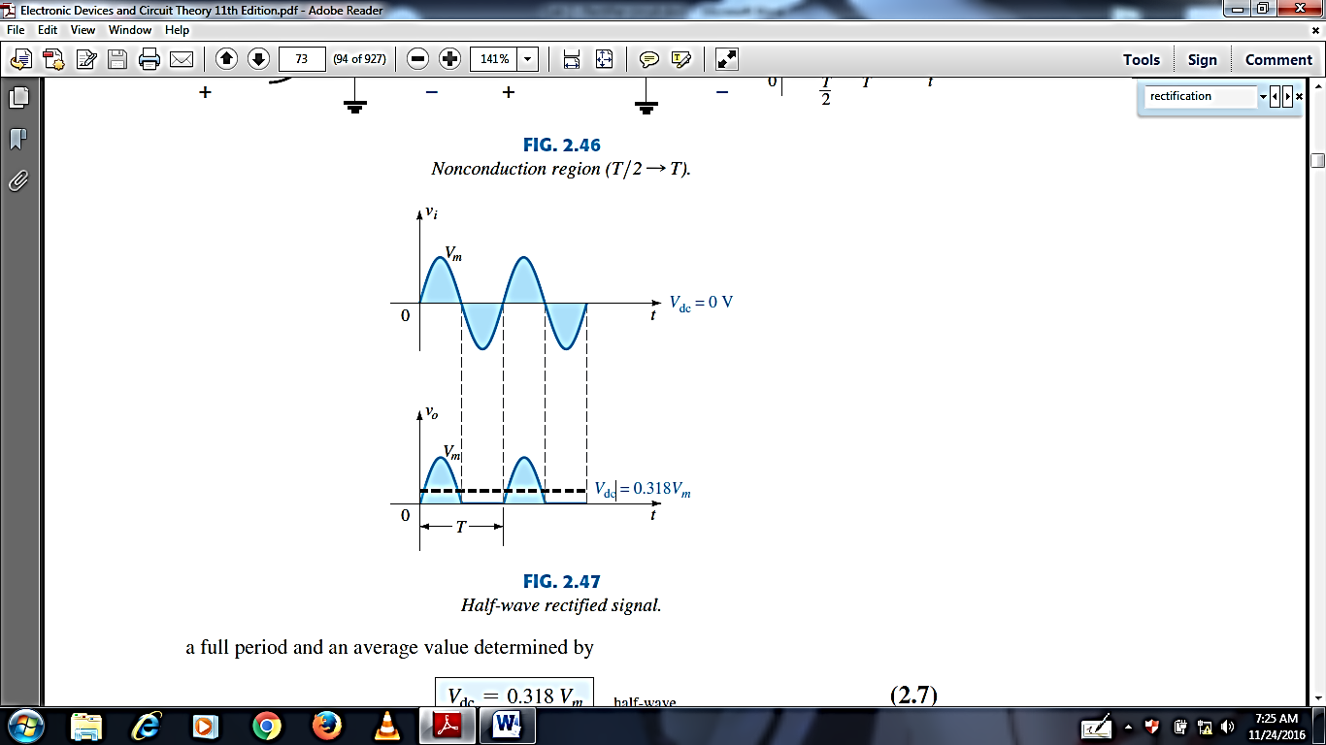

Figure 4: Half wave rectified signal

The dc level obtained from a sinusoidal input can be improved 100% using a process called *full-wave rectification*. The most familiar network for performing such a function appears in figure 5 with its four diodes in a *bridge* configuration. During the period *t =* 0 to *T/*2 the polarity of the input is as shown in figure 6. The resulting polarities across the ideal diodes are also shown in figure 6 to reveal that *D*2 and *D*3 are conducting, whereas*D*1 and *D*4 are in the “off” state. The net result is the configuration of figure 7, with itsindicated current and polarity across *R*.

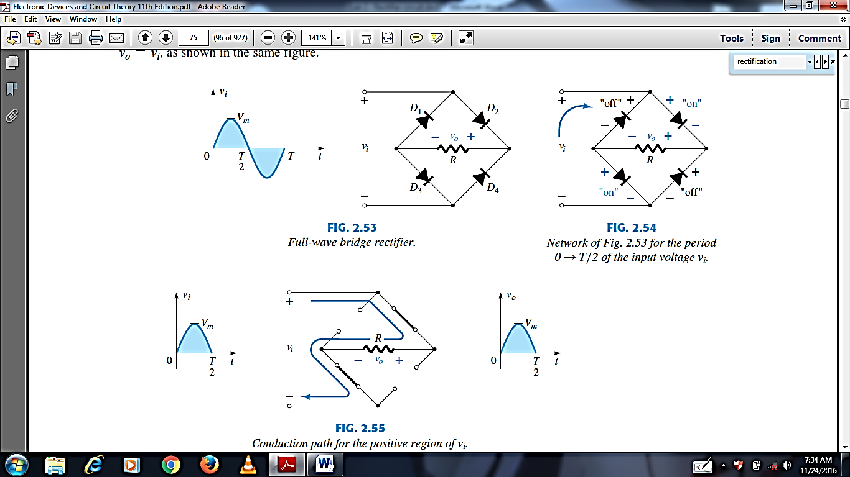

Figure 5: Full wave bridge rectifier Figure 6: network for period 0 to T/2

of the input voltage



Figure 7: Conduction for the positive part of vi

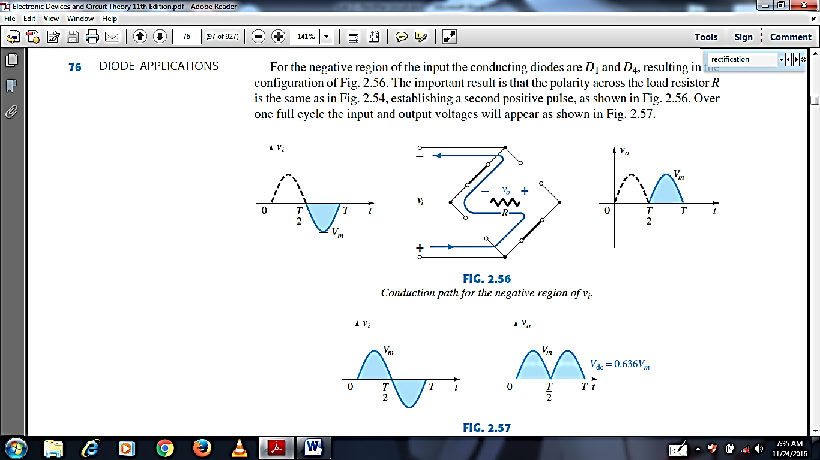

Figure 8: conduction for the negative part of vi

**Lab – 2: Rectifier Circuits**

**Objectives:**

* To analyze the action of half wave and full wave rectifier circuits.
* To observe the effect of capacitor and load resistor on filtering (smoothing) the output of half wave and full wave rectifiers.

**Apparatus Used:**

**Instruments:**

* Variable AC power supply
* Digital Multimeter (DMM)



* Oscilloscope

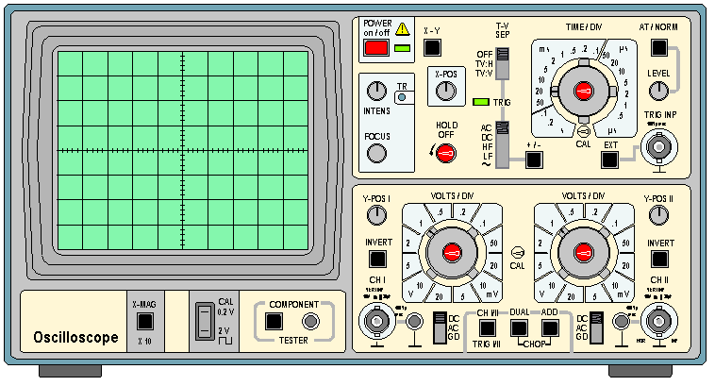

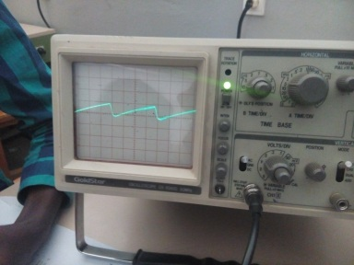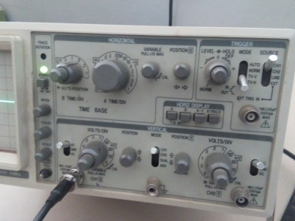

* Connecting wires
* Breadboard

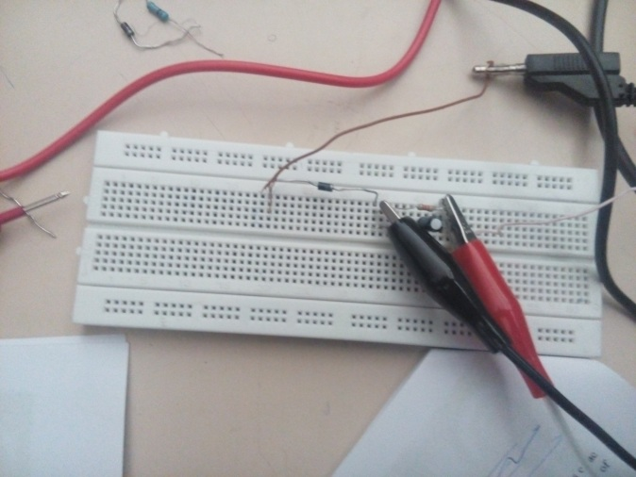

**Components:**

* Diodes: Silicon (1N4007)

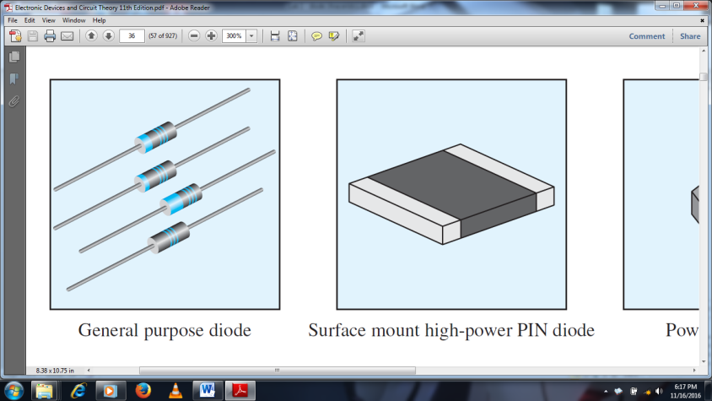

* Resistors: 1k $Ω$, 10k $Ω$
* Electrolytic Capacitors: 47 $μ$ F, 220 $μ$ F

**Procedures**

1. Before starting our experiment our lab assistant showed us how to use supplying instruments like Oscilloscope, AC and DC power supply and the like.
2. On oscilloscope we were shown the following points:
   1. How to adjust the focus on the display.
   2. How to adjust the vertical and horizontal positioning of our graph.
   3. How to adjust voltage per division and time per division.
3. While enacting our experiment we were shown how to connect the oscilloscope to our circuit.
4. We were also shown how to adjust the output of the AC power supply to the desired amount of voltage.

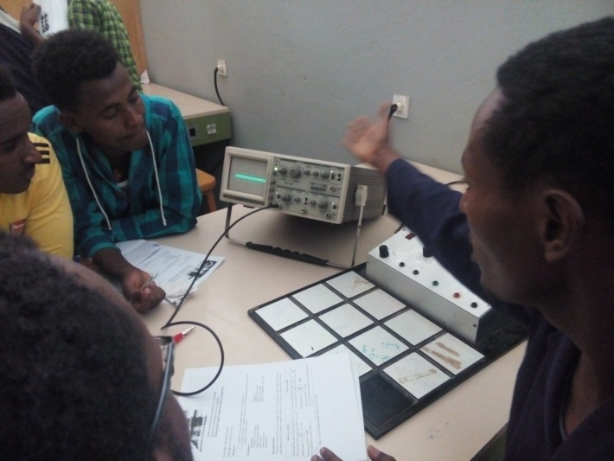

Figure: students being assisted by lab assistant during experiment

1. **Half wave rectification**
2. We adjusted the output voltage of the AC power supply to 10 V. Then we adjusted the voltage per division to 5V. And when we connected the power source we obtained a graph in the boundary of two divisions, thus making the peak to peak voltage to 10 V. Since the required frequency was 50 Hz, we also adjusted the time per division to 5 ms so as to give us this frequency.
3. Then we constructed the required circuit on the breadboard. The circuit has a wire coming out of the AC source to the cathode terminal of the diode. Here no problem will arise from not taking into consideration of the polarity of the source. This is because the AC source has an alternating polarity. Then a wire connects the diode to a resistor (2.2 k $Ω$ resistor in this particular case). Then a wire goes from the resistor back to the AC source.
4. Here we recorded the DC output voltage by measuring the voltage across the resistor by using a digital Multimeter (DMM). Also we observed the output signal from the oscilloscope by connecting the two probes of the oscilloscope to the resistor. We are ought to take caution here because the current passing through the diode and entering the resistor has no more alternating polarities. The resistor has a defined polarity unlike the AC source. Thus we took caution in connecting the oscilloscope to the resistor.
5. Then we placed the diode in reverse direction. Meaning the initial wire emanating from the source goes to the anode terminal instead of the cathode terminal. Here also we read the DC output voltage at the resistor and observed the output wave form from the oscilloscope by connecting it just as we mentioned before. Here the DC output is not a pure DC rather it is pulsating.
6. After this we connected a 47 $μ$ F in parallel the load resistor. The main purpose of the capacitor is to filter out the pulsation of the output DC voltage. We measured thethe DC output voltage and peak value of the ripple voltage.
7. Then we replaced the capacitor by 220 $μ$ F. Here also we measured the DC output voltage at the resistor and the ripple factor.
8. Finally we replaced the 2.2 k $Ω$ load resistor by a 10 k $Ω$ resistor and we measured the output voltage at the resistor and the ripple voltage.
9. **Full wave rectification**
10. Here again we adjusted the output voltage of the AC power supply to 10 V. And set the time per division to 5 ms so as to obtain a frequency of 50Hz. And just like as we did with the half wave rectification, we observed the display of the wave form that the AC source gives when connected to an oscilloscope.
11. Then we connected the 4 diode as shown in figure 5. Following this we read the voltage measurement at the resistor by using a DMM.
12. Then we determined the output frequency.
13. After this we replaced D3 and D4 of circuit by two 2.2k $Ω$ resistors. Right after this we witnessed the display of the output wave form and recorded the DC output voltage. Here the effect of replacing the diodes with the resistors is seen by the output wave form which shows a decrease in amplitude of some parts of the graph.
14. After doing the above returned the diodes and we connected a 47 $μ$ F in parallel to the load resistor and observed the wave form on the oscilloscope. We measured the DC voltage and peak value of the ripple voltage.
15. Then we replaced the 47 $μ$ F capacitor with a 220 $μ$ F capacitor and measured the DC voltage at the resistor and peak value of the ripple voltage.
16. At the final stage of our full wave rectifier experiment we replaced the 2.2 k $Ω$ load resistor with a 10 k $Ω$ resistor. As usual we measured the DC output voltage at the newly placed load resistor and we also measured the peak value of the ripple voltage.

**Result and Discussion**

From the experiments we have done we have obtained the following measurements.

**Half wave Rectifier**

Vout = VRL

RL

2.2 k $Ω$

AC input signal

+

-a>

* The DC output voltage obtained is as follows:

VRL = VDC = **4.19 V**

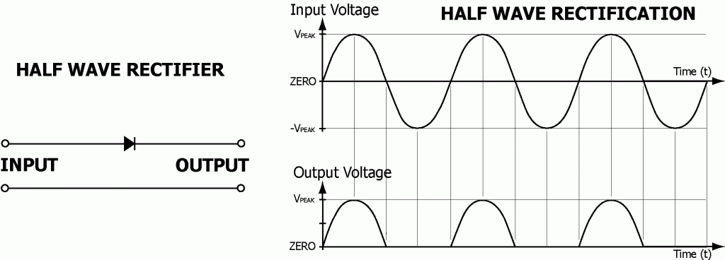

Figure: The DC output for half wave rectification

* The output frequency is as follows: (time per division = 5 ms)

fout = **50 Hz**

* The DC output voltage when the direction of the diode is reversed, the measurement we got is as follows:

VRL= **4.23 V**

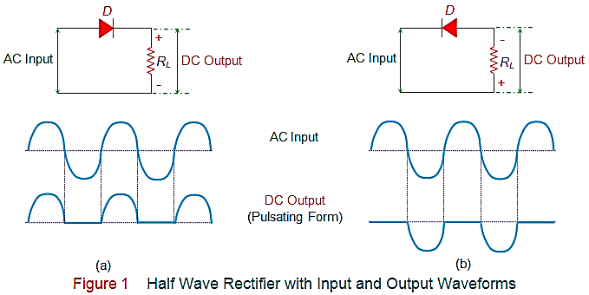

Figure: The DC output for half wave rectification (reverse direction)

* When a capacitor of 47 $μ$ F is connected to a half wave rectifier, we obtained the following measurements:

VRL = 11.95 V Vr = 0.65 V

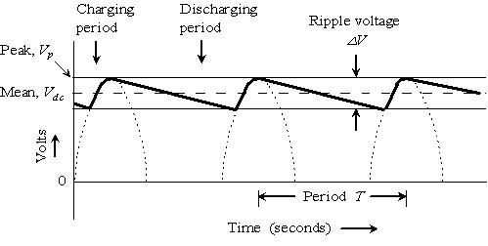

Figure: Filtering by capacitor

* When the previous capacitor is replaced by a 220 $μ$ F, we obtained the following measurements:

VRL= 12.66 V Vr = 0.13 V

**Full wave Rectifier**

* We obtained the following output voltage for a full wave rectifier shown in the figure 5:

VDC= VRL = **7.74 V**



Figure 5: full wave rectifier

* When the complete circuit is connected to an AC source we obtained the following output frequency: (time per division = 10 ms)

fout= **100 Hz**

* When D3 and D4 of circuit of figure 5 by two 2.2 k $Ω$ resistors, we obtained the following measurements:

VDC = **2.41 V**

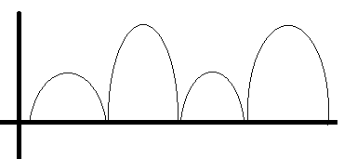

Figure: The change that occurs when two diodes are replaced by two resistors

* When a 47 $μ$ F capacitor in parallel with the load resistance we measured the following DC voltage and peak value of the ripple voltage:

VRL = **11.97 V**  Vr = **0.3 V**

* When the above capacitor is replaced by a 220 $μ$ F capacitor we obtained the following measurements:

VRL = **7.65 V** Vr = **0.06 V**

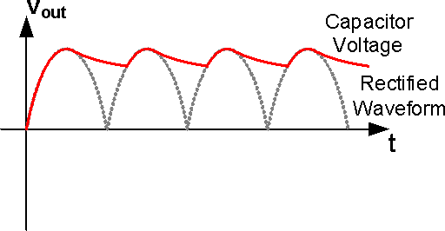

* Finally when we replaced the 2.2 k $Ω$ load resistor is replaced by a 10 k $Ω$ resistor we obtained the following readings:

VRL= **12.52 V** Vr = **0.02 V**

**Observations and Conclusion**

* We have observed the following points:
* If one of the diodes is open in the full wave rectifier we will obtain a half wave rectification.
* If one of the diodes is shorted, the shorted path will allow the passage of uncertified current causing an impact on the final output dc voltage. Hence it increases the pulse of the output.
* If any of the two diodes connected in series are open then the final wave form will lose half of the wave. Meaning the rectification will become half wave rectification and half of the input voltage will not be seen on the output DC voltage.

**References**

* Electronic devices and circuit Theory 10th edition, R. L. Boylestad and L. Nashelsky

**Thank you!**